Lab Assignment 01

Name: Abdul Rehman Riaz
CMS ID: 542715
Github: https://github.com/SolitaryRehman/DSA-Labs
Task: 1

Create an array named numbers containing 2, 4, 6, 8 and 10. Change the third element to 7. Use a for loop to display all five values, separated by spaces. Predict the output before running your program.

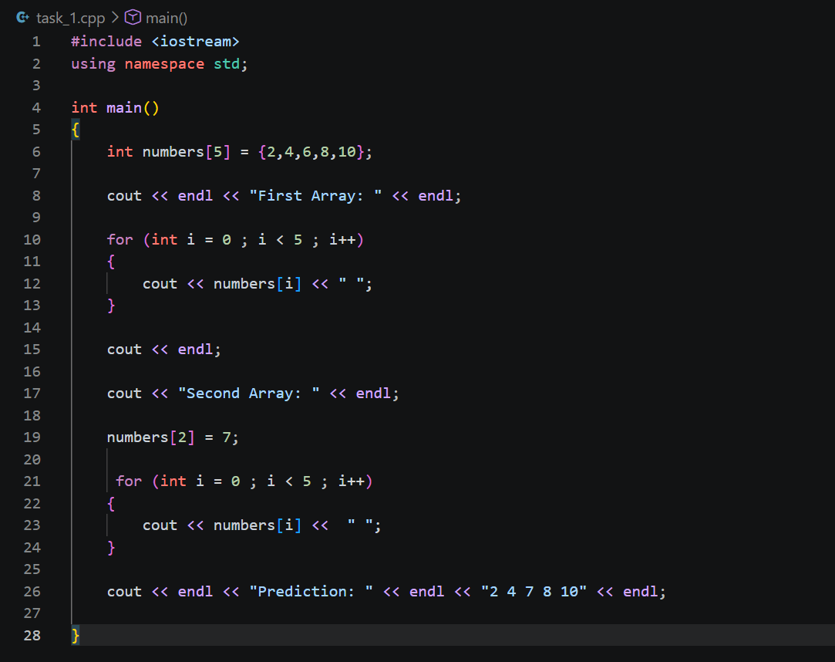
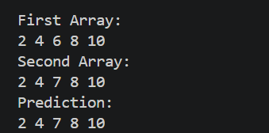

Task: 2
Declare int numbers[5]; and initialise int total = 0;. Use one loop to read five integers into the array and a second loop to add them to total. Display the total. Assume the user enters exactly five valid integers whose sum fits in int.
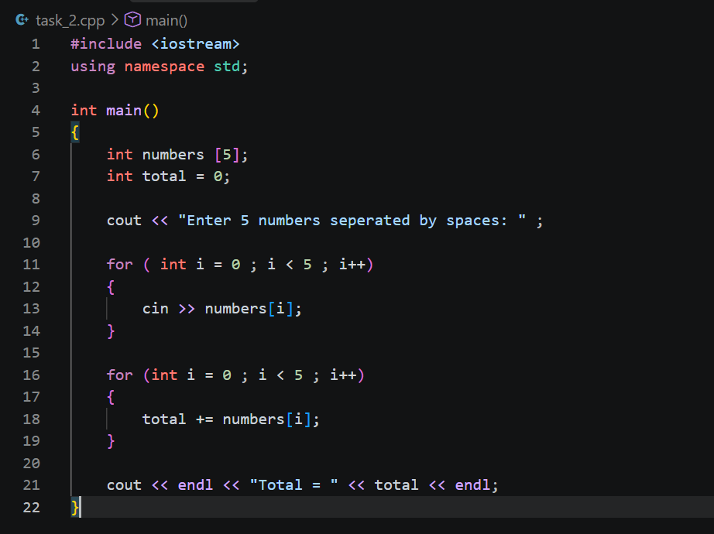
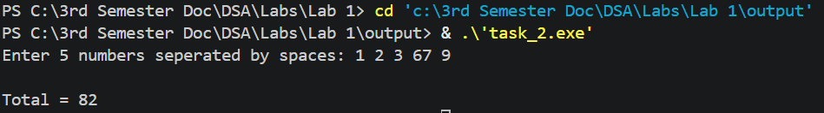
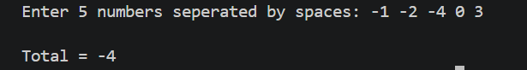
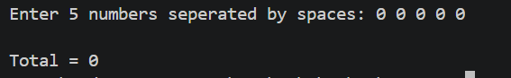

Task: 3
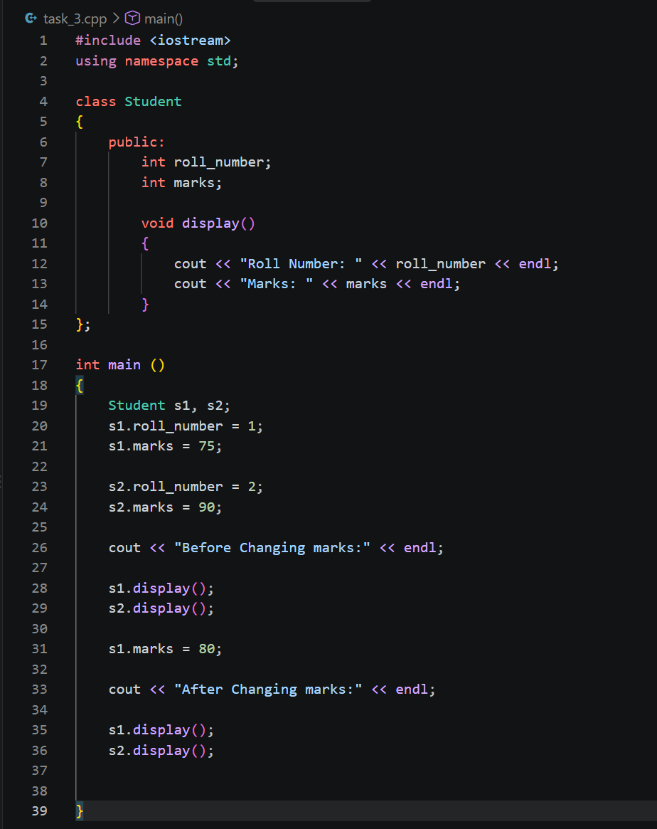
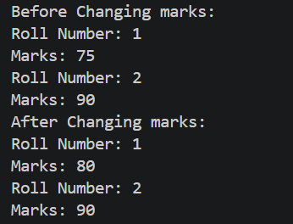
Since we only changed student 1’s marks so student 2’s marks are not changed.

Task: 4
Read 8 integers into an array. Find and display the largest and smallest values and their indices. If a value occurs more than once, report its first occurrence.

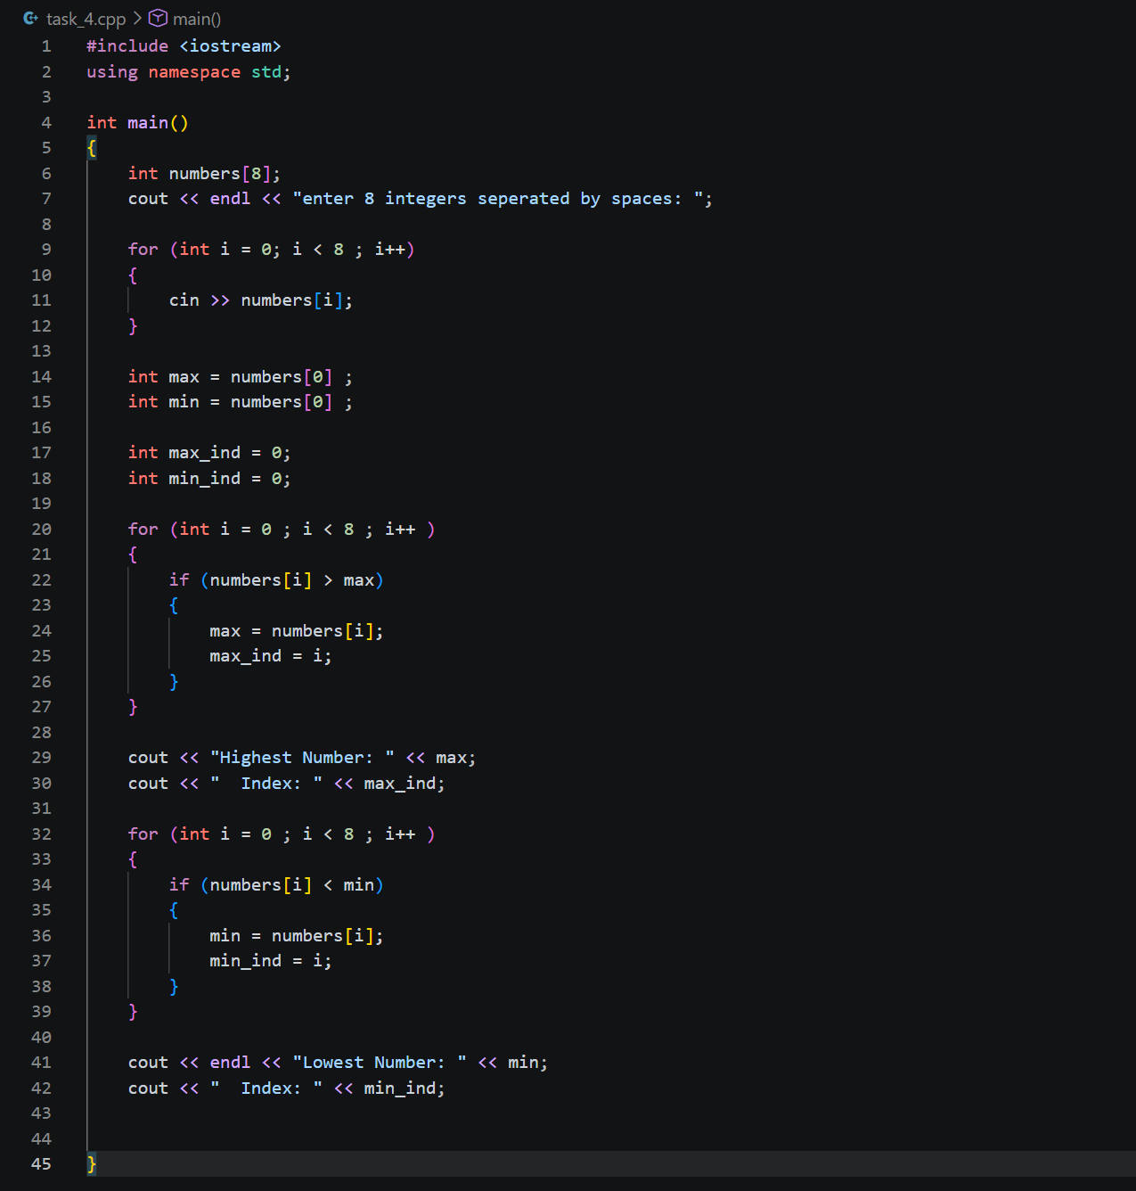
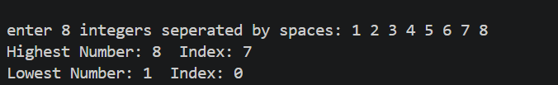
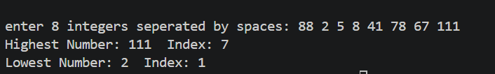

Task: 5
Read 8 integers into an array. Find and display the largest and smallest values and their indices. If a value occurs more than once, report its first occurrence.

Task: 6
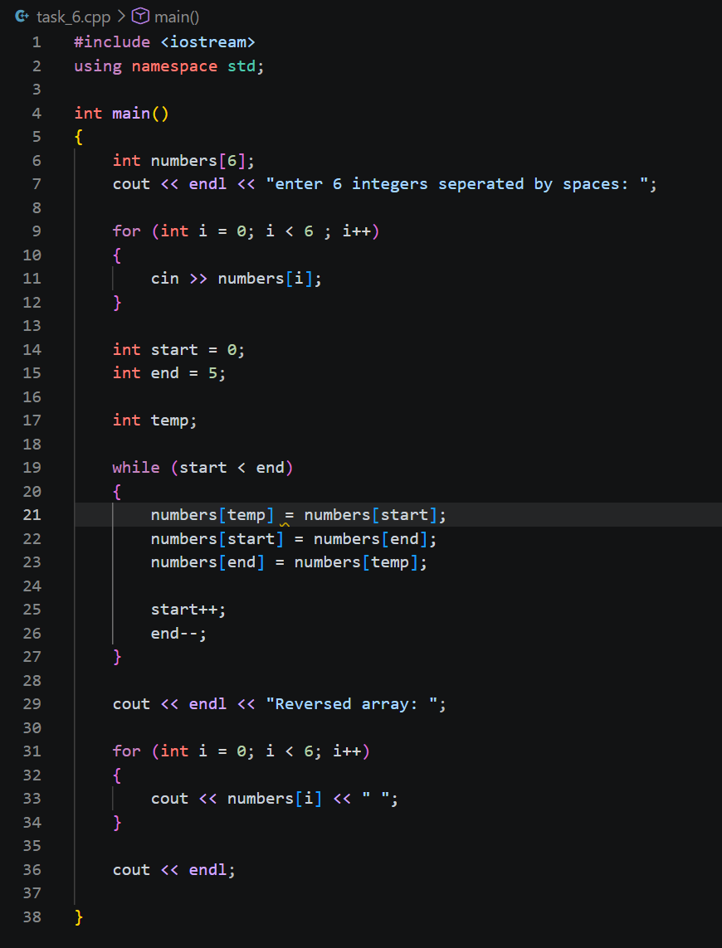
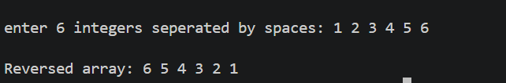
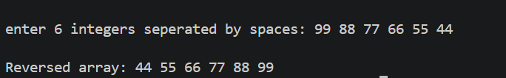

Task: 7
Read 10 integers into an array. Move the first occurrence of each distinct value into the beginning of the same array, preserving the original order. Display these unique values and their count. Do not use another array.
Example: {4, 2, 4, 7, 2, 9, 7, 1, 9, 1} produces {4, 2, 7, 9, 1}, with a count of 5.
The array’s physical capacity remains 10; only the first 5 positions represent the result.

